Contents

001 2

M11_EscapeVelocity 3

M13_Observatory 4

M10_FoodProduction 5

M12_SatelliteOrbits 6

ReturnToBase_M12_M00 7

M02_SolarPanelArray 8

M01_SpaceTravel 9

M05_Extraction 10

M03_3DPrinting 12

SpaceTravelDump 14

OtherSPA 15

MENU 17

## 001

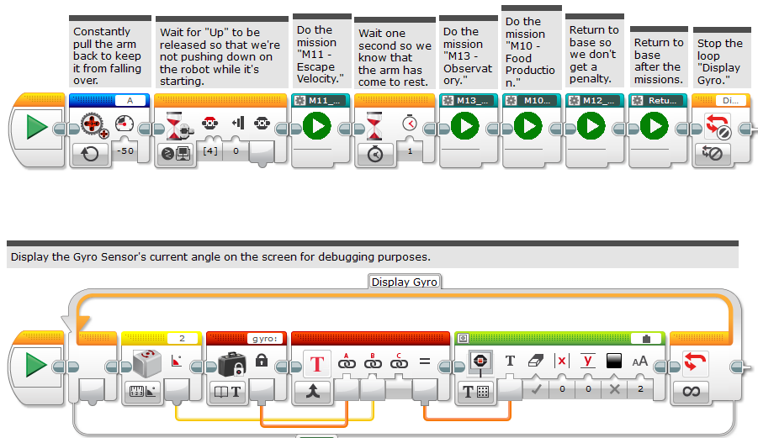

## M11_EscapeVelocity

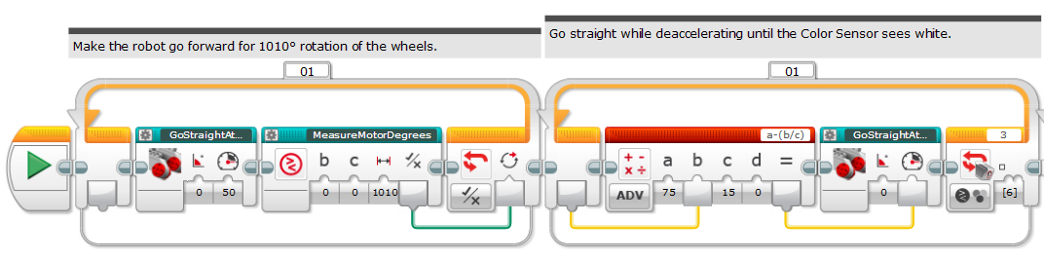

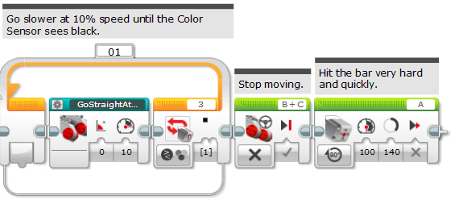

## M13_Observatory

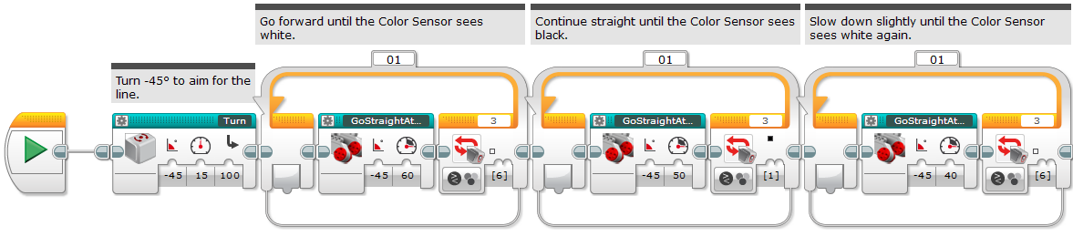  
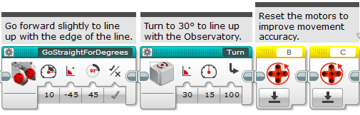

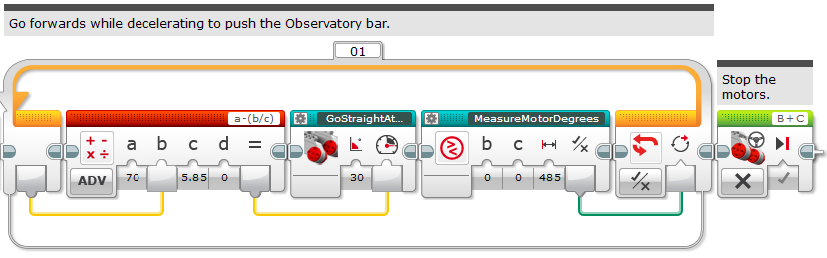

## M10_FoodProduction

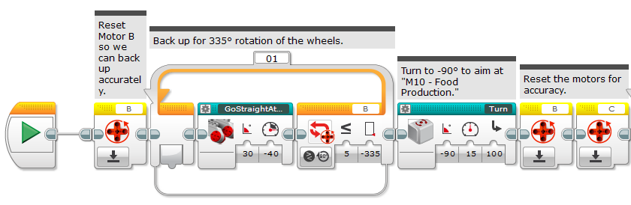

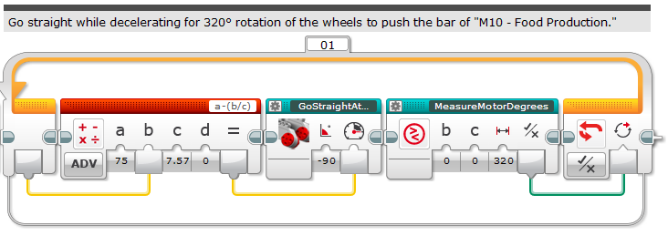

## M12_SatelliteOrbits

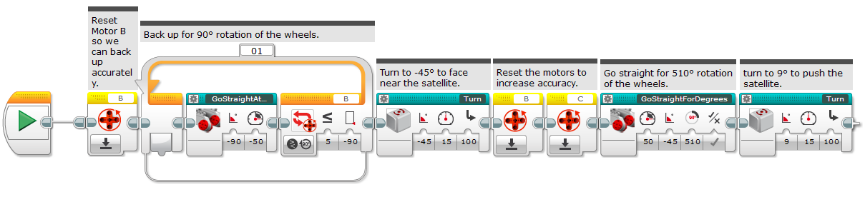

## ReturnToBase_M12_M00

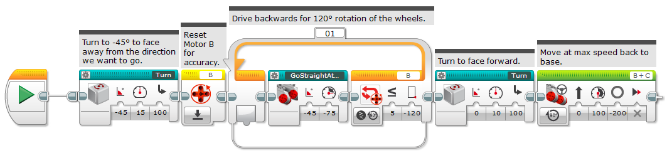

## M02_SolarPanelArray

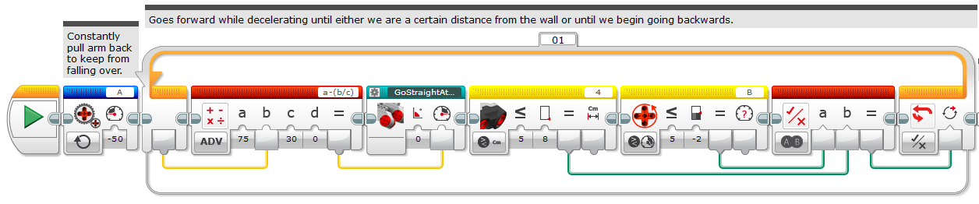

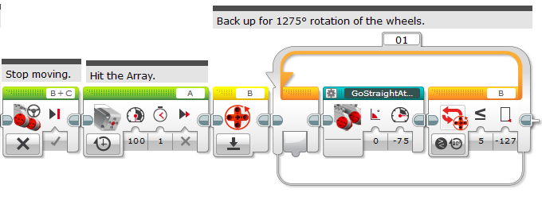

## M01_SpaceTravel

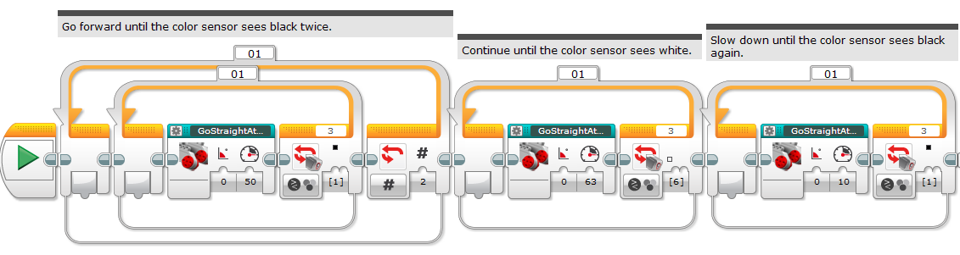

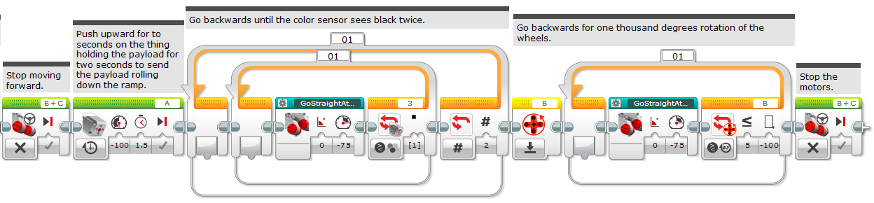

## M05_Extraction

(page 1 of 2)

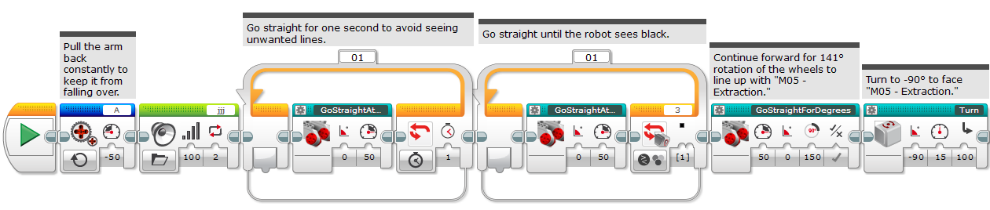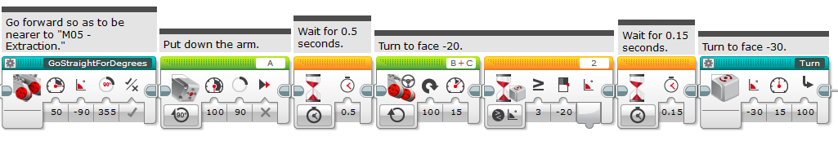

(continued on next page)

M05_Extraction (page 2 of 2)

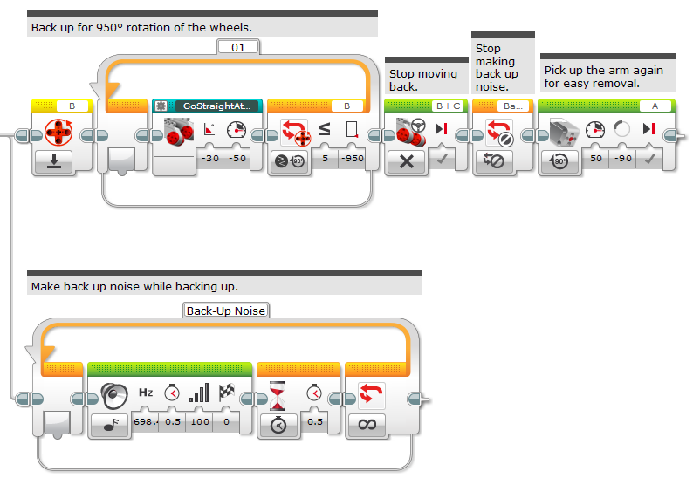

## M03_3DPrinting

(page 1 of 2)

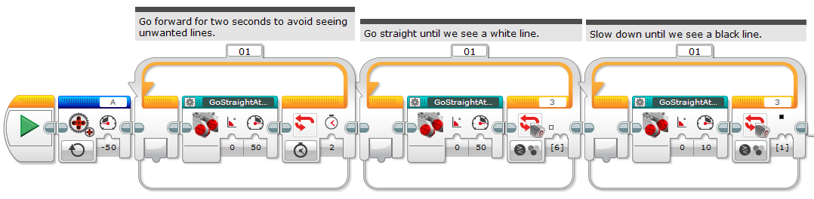

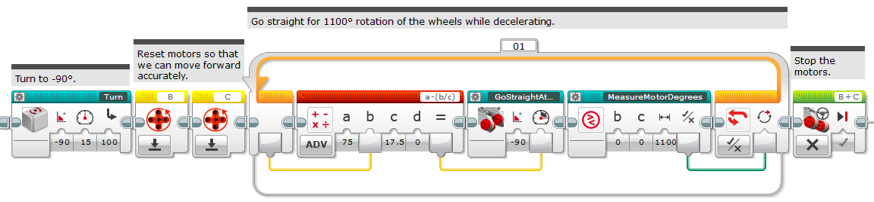

(continued on next page)

M03_3DPrinting (page 2 of 2)

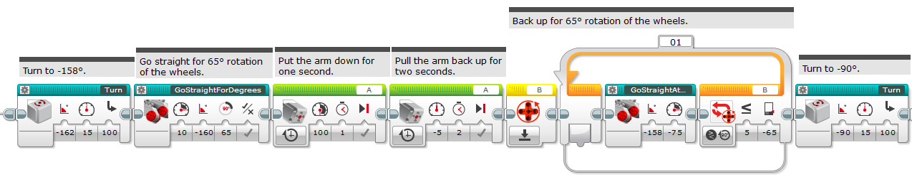

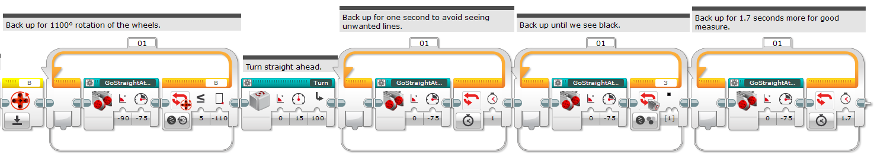

## SpaceTravelDump

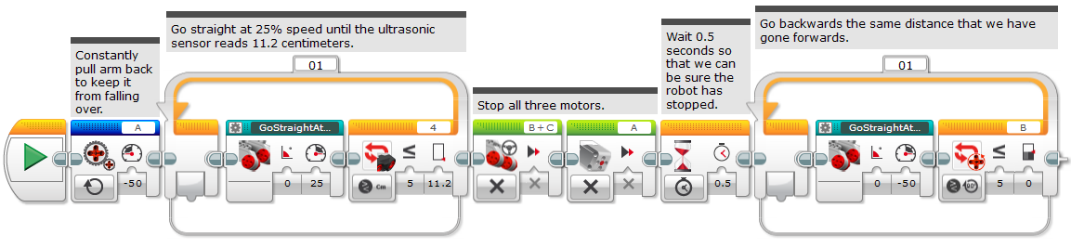

## OtherSPA

(other team’s Solar Panel Array, page 1 of 2)

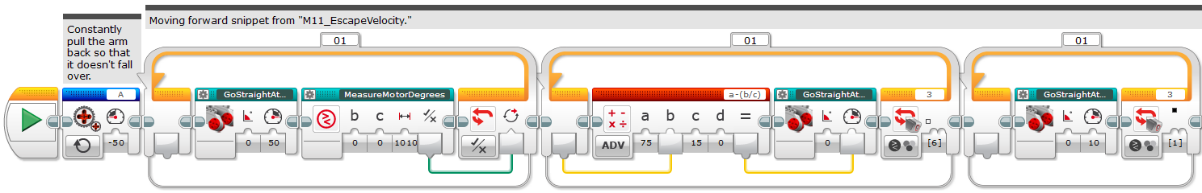

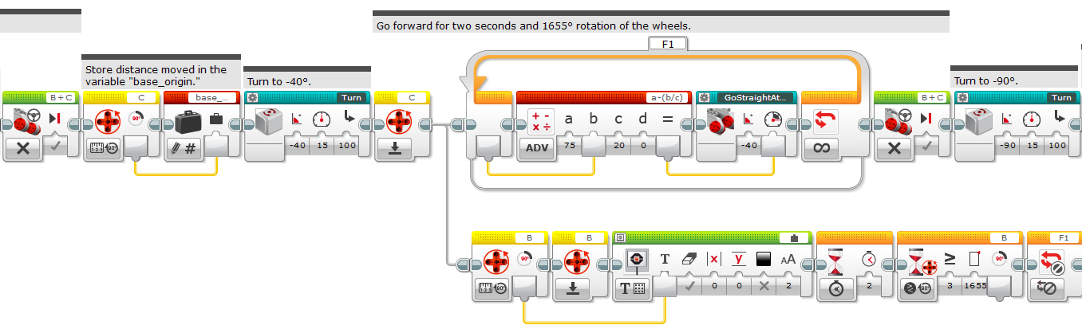

(continued on next page)

OtherSPA (page 2 of 2)

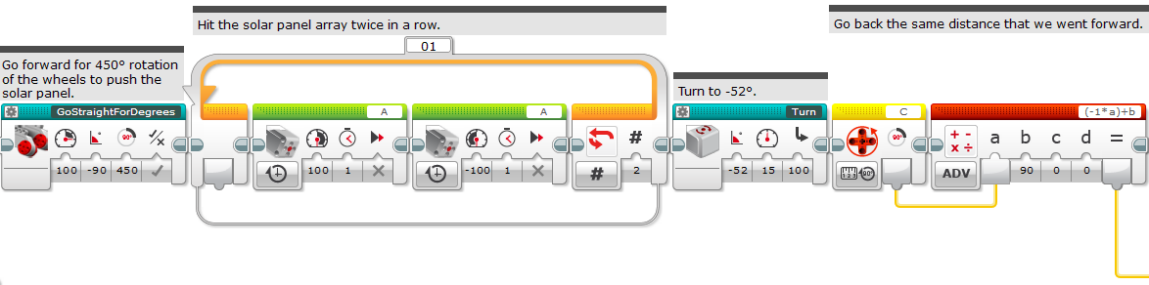

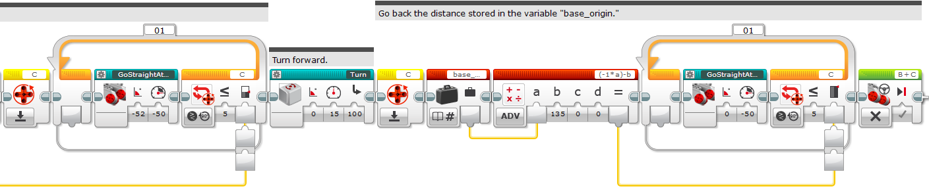

## MENU

(page 1 of 2)

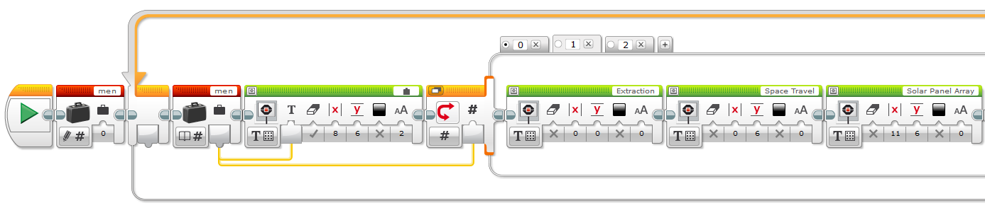

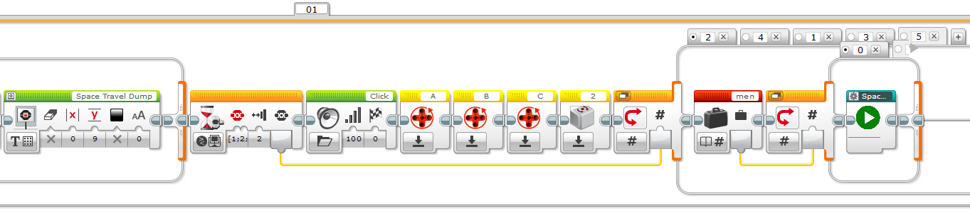

(continued on next page)

MENU (page 2 of 2)

